E.Hybrid WAN (SD-WAN) : Introduction to SD-WAN, Key Benefits of SD-WAN
Tasks
1.Create a comparison table listing at least 5 key differences between traditional WAN and SD-WAN, focusing on how data is routed, managed, and secured.

Feature | Traditional WAN | SD-WAN
Data Routing | Traffic is usually routed through fixed MPLS links and centralized data centers. | Traffic is dynamically routed across multiple connections (MPLS, broadband, LTE/5G) based on application requirements and network conditions.
Management | Configuration and management are performed manually on individual network devices. | Centralized management through a software-based controller and dashboard.
Security | Security often relies on separate firewalls and security appliances at branch locations. | Built-in security features such as encryption, segmentation, and secure tunnels across all connections.
Network Flexibility | Adding new sites or changing configurations can be time-consuming and complex. | New sites can be deployed quickly using centralized policies and automated provisioning.
Performance Optimization | Limited ability to prioritize applications and adjust routes automatically. | Uses application-aware routing to optimize performance and prioritize critical applications.
Cost | Generally more expensive due to dependence on dedicated MPLS circuits. | Often reduces costs by utilizing lower-cost internet connections alongside or instead of MPLS.
Visibility and Monitoring | Limited real-time visibility into application and network performance. | Provides real-time analytics, monitoring, and reporting through a centralized dashboard.

2.Draw a simple network diagram (on paper or using a tool like draw.io) showing how SD-WAN connects multiple branch offices to cloud apps (like Office 365 or AWS) and the main data center. Label the SD-WAN controllers, edges, and at least two types of WAN links (e.g., MPLS, broadband).
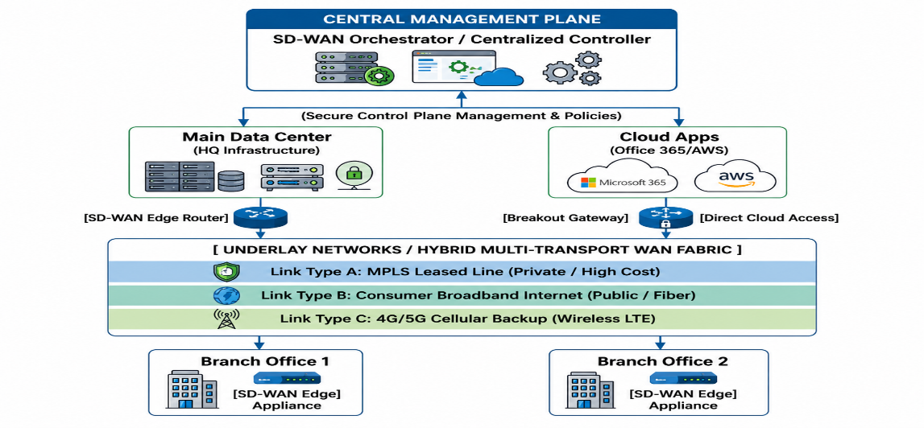

Simple Explanation of the SD-WAN Diagram
- Central Management Plane: Controls and manages the entire network from one place.
- Main Data Center: Stores company servers, applications, and data.
- Cloud Apps: Services like Microsoft 365 and AWS that users access over the internet.
- SD-WAN Edge Devices: Installed at branch offices to connect them to the network.
- Underlay Networks: Different connection types used for communication:
  - MPLS: Private and reliable but expensive.
  - Broadband Internet: Public, fast, and cheaper.
  - 4G/5G: Backup connection if other links fail.
- How it Works: SD-WAN automatically chooses the best available connection for traffic, ensuring better speed, security, and reliability.
3.Pick any app you use daily (like WhatsApp, Zomato, or Instagram) and write a short scenario explaining how SD-WAN could improve user experience for that app when used across multiple cities in India.Hint:</strong> Think about speed, reliability, and security when users access the app from different locations.
Example Scenario: WhatsApp and SD-WAN
Suppose a company uses WhatsApp to communicate with employees in Mumbai, Delhi, Bengaluru, and Surat. Without SD-WAN, messages and calls may experience delays if the network is congested.
With SD-WAN, the network automatically selects the fastest and most reliable connection (MPLS, Broadband, or 4G/5G). This ensures that WhatsApp messages, voice calls, and video calls are delivered quickly and smoothly. If one connection fails, SD-WAN instantly switches to another available link without interrupting communication. It also encrypts data, improving security.
4.List and explain three key benefits of SD-WAN for a company with offices in Ahmedabad, Mumbai, and Bangalore. For each benefit, give a real-world example of how it would help employees or customers.

Benefit | Explanation | Real-World Example
1. Better Performance | SD-WAN automatically chooses the fastest and most reliable network path for applications and data. | Employees in Ahmedabad, Mumbai, and Bangalore can attend video meetings on Microsoft Teams without lag or interruptions.
2. Lower Costs | SD-WAN can use affordable broadband internet along with MPLS, reducing networking expenses. | The company saves money on expensive leased lines while still maintaining good connectivity between all offices.
3. Improved Reliability and Security | If one network link fails, SD-WAN automatically switches to another available connection. It also encrypts data for secure communication. | If the internet connection in the Mumbai office goes down, employees remain connected through a backup link, allowing customer support services to continue without disruption.

